Price Increase Sequence for NON Clients

Email 1 -- send 2 weeks out from price increase date.

Subject: PRICE INCREASE -- come in today for the best deal! (time sensitive)

Hey, I’ll keep this quick because time is of the essence…

On [DATE] I’m going to increase my prices by 10% -- but ONLY NEW members.

That means all my current members will stay at their current rate…

...and YOU can get my ultimate fat-burning transformation program for the best deal I’ll ever offer -- and you’ll be grandfathered in FOR LIFE at this lower price!

And in case you’ve been “on the fence” about joining us at Fit Body Boot Camp, let me make this even easier for you..

Come in any time before [DATE] and I’ll give you two free weeks of boot camp!

That way, you can see the fast results, positive community, and smart, lifestyle-friendly nutrition coaching for yourself and see if Fit Body Boot Camp is right for you.

And as long as you make your decision to sign up as a VIP member before [DATE], you’ll be grandfathered in FOR LIFE at my current low membership rate.

But [DATE] is coming up fast, and I can only offer those two free weeks BEFORE then -- so don’t wait!

Come in today (or reply to this email or call [PHONE NUMBER]) and see the incredible fat loss results only Fit Body Boot Camp can deliver…

And for a sneak peek, check out these stories from real clients:
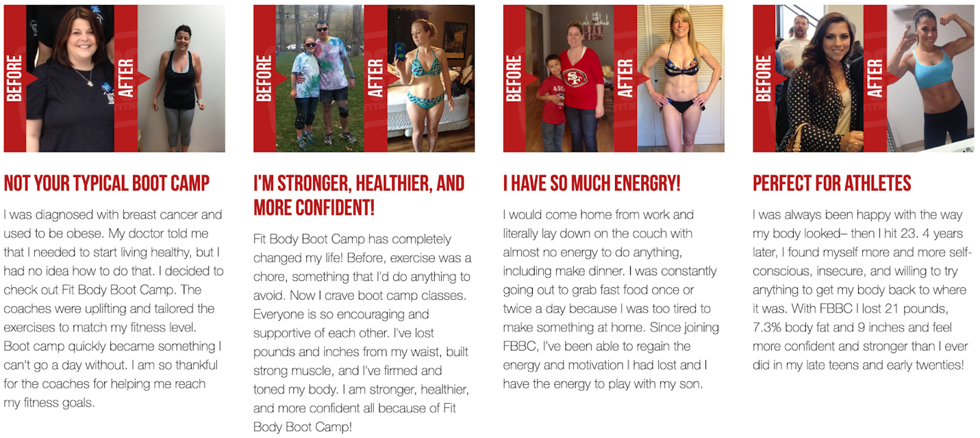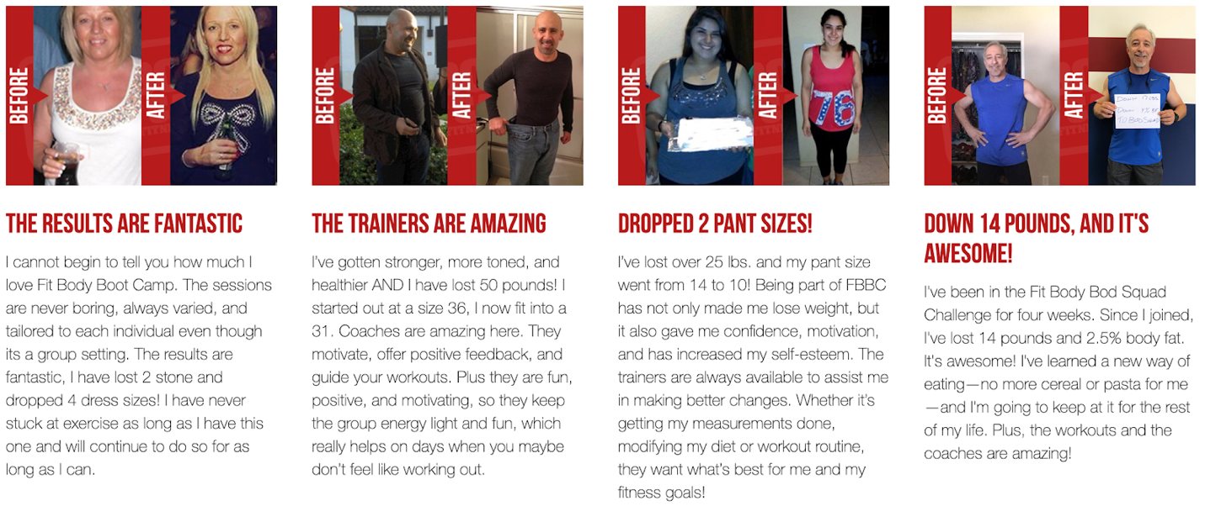

With 2 free weeks, you truly have nothing to lose -- only the once in a lifetime opportunity to get the body and healthy lifestyle of your dreams for the lowest price I’ll EVER offer again.

BUT ONLY IF YOU COME IN OR REACH OUT BEFORE [DATE]!!

Talk soon,

[SIGN OFF]

Email 2 -- send one week out from price increase date

Subject: did you see this? (time sensitive)

Hey, I sent you an email a week ago to let you know about my price increase coming up…

...and I noticed you still haven’t started your 2 week trial, which means you might miss out on the best deal I’m ever going to offer on training!

Maybe you missed the message, so here’s what I sent before:

On [DATE] I’m going to increase my prices by 10% -- but ONLY for new members.

That means all my current members will stay at their current rate…

...and YOU can get my ultimate fat-burning transformation program for the best deal I’ll ever offer -- and you’ll be grandfathered in FOR LIFE at this lower price!

And in case you’ve been “on the fence” about joining us at Fit Body Boot Camp, let me make this even easier for you..

Come in any time before [DATE] and I’ll give you two free weeks of boot camp!

That way, you can see the fast results, positive community, and smart, lifestyle-friendly nutrition coaching for yourself and see if Fit Body Boot Camp is right for you.

And as long as you make your decision to sign up as a VIP member before the end of those 2 free weeks, you’ll be grandfathered in FOR LIFE at my current low membership rate.

But [DATE] is coming up fast, and I can only offer those two free weeks BEFORE then -- so don’t wait!

Come in today (or reply to this email or call [PHONE NUMBER]) and see the incredible fat loss results only Fit Body Boot Camp can deliver…

And for a sneak peek, check out these stories from real clients:

With 2 free weeks, you truly have nothing to lose -- only the once in a lifetime opportunity to get the body and healthy lifestyle of your dreams for the lowest price I’ll EVER offer again.

BUT ONLY IF YOU COME IN OR REACH OUT BEFORE [DATE]!

Talk soon,

[SIGN OFF]

Email 3 -- send this 2 days before price increase.

Subject: 48 HOURS LEFT -- best price EVER on fat loss

Heads up: only two days left before I raise my prices permanently for all NEW members.

That means for the next 48 hours only, you can sign up and be grandfathered in FOR LIFE at my lowest rate -- and get a bargain on the weight loss and ideal body you desire!

And, truth be told, I’m bending the rules for a little bit because I know you’ve been thinking about Fit Body Boot Camp for a while now.

If this is the nudge you need to finally achieve your dream body, take back control of your health find your confidence again, and experience a head-turning physical transformation…

Then I’m happy to bend the rules for you!

So here’s the deal: reply to this email, call me at [PHONE NUMBER] or come into boot camp within the next 48 hours and I’ll start you on a 2 WEEK FREE TRIAL with the option to take advantage of my current, low membership rate at the end.

Yes, this means you’ll technically be past the deadline for the price increase…

BUT, I want to make sure you’re 100% confident in your decision to sign up, which is why I’m giving you those 2 week free.

Take the two week trial and see if the fast results, positive community, and smart, lifestyle-friendly nutrition coaching here at Fit Body Boot Camp is right for you.

And for a sneak peek, check out these stories from real clients:

With 2 free weeks, you truly have nothing to lose -- only the once in a lifetime opportunity to get the body and healthy lifestyle of your dreams for the lowest price I’ll EVER offer again.

BUT ONLY IF YOU COME IN OR REACH OUT WITHIN THE NEXT 48 HOURS!

Talk soon,

[SIGN OFF]

