Price Increase Sequence for Clients

Email 1 -- send 2 weeks out from price increase

Subject: New science on weight gain and weight loss (time sensitive!!)

Hey, I was doing some research the other day and I found this crazy fact I just had to share with you:

In the US and Western Nations, 70% of adults are overweight and 37% are obese...and scientists predict that almost 100% will be overweight by 2048!

Pretty shocking...and I have to admit, pretty scary.

But to me, this just lights a fire under my butt to keep coaching and delivering results here at Fit Body Boot Camp.

In fact, there’s really two BIG THINGS I know I must do to play my part in fighting the overweight and obesity crisis:

- I need to invest more in my team and myself to make us even better fitness coaches -- which means more education and resources we can use to give YOU better results.
- I need to add more members to our boot camp family, who can not only transform their own lives but become positive role models in the community.

THIS IS WHERE I NEED YOUR HELP!

See, I’m raising my membership rates for NEW clients starting on [DATE].

Don’t worry -- YOU are already grandfathered in on your current rate. This will only affect new members who sign up after [DATE].

And, of course, I want to spend as much of that money as possible on better education and resources for the team, which means even better results for you.

So here’s where you come in…

I’m offering your friends and family a 2 WEEK FREE TRIAL between now and [DATE] and anyone who chooses to continue after the trial will be grandfathered in at the current membership rate!

You know better than anyone the impact of being part of the Fit Body Family...and I’m guessing you can think of at least 3 people off the top of your head who could use our help.

So, go ahead and forward this email to them right now and let them know they can reach me at [EMAIL] or [PHONE] or simply walk into boot camp and let us know you sent them.

NOW LET’S GO CHANGE SOME LIVES!

See you in boot camp,

[SIGN OFF]

Email 2 -- send 1 week out from price increase

Subject: FWD: did you see this? (time sensitive!!)

Hey, remember what I said earlier about offering a free 2 week trial before the price increase on [DATE]?

(BTW, you don’t have to worry about the price increase because you’re already grandfathered in. This only affects new members after [DATE].)

Well, because this is such a great deal and could be a life-changing opportunity for someone, I want to make sure this message reaches as many people as possible.

Please forward this to any friends or family looking to burn fat, tone up, and look and feel their best!

---------- Forwarded message ---------
From: [YOUR EMAIL]
Date: [TODAY’S DATE]
Subject: did you see this?
To: XXXXX

Hey, quick reminder for you...

On [DATE] I’m going to increase my prices by [PERCENTAGE] -- but ONLY for new members.

That means all my current members will stay at their current rate…

...and YOU can get my ultimate fat-burning transformation program for the best deal I’ll ever offer -- and you’ll be grandfathered in FOR LIFE at this lower price!

And in case you’ve been “on the fence” about joining us at Fit Body Boot Camp, let me make this even easier for you..

Come in any time before [DATE] and I’ll give you two free weeks of boot camp!

That way, you can see the fast results, positive community, and smart, lifestyle-friendly nutrition coaching for yourself and see if Fit Body Boot Camp is right for you.

And as long as you make your decision to sign up as a VIP member before the end of those 2 free weeks, you’ll be grandfathered in FOR LIFE at my current low membership rate.

But [DATE] is coming up fast, and I can only offer those two free weeks BEFORE then -- so don’t wait!

Come in today (or reply to this email or call [PHONE NUMBER]) and see the incredible fat loss results only Fit Body Boot Camp can deliver…

And for a sneak peek, check out these stories from real clients:
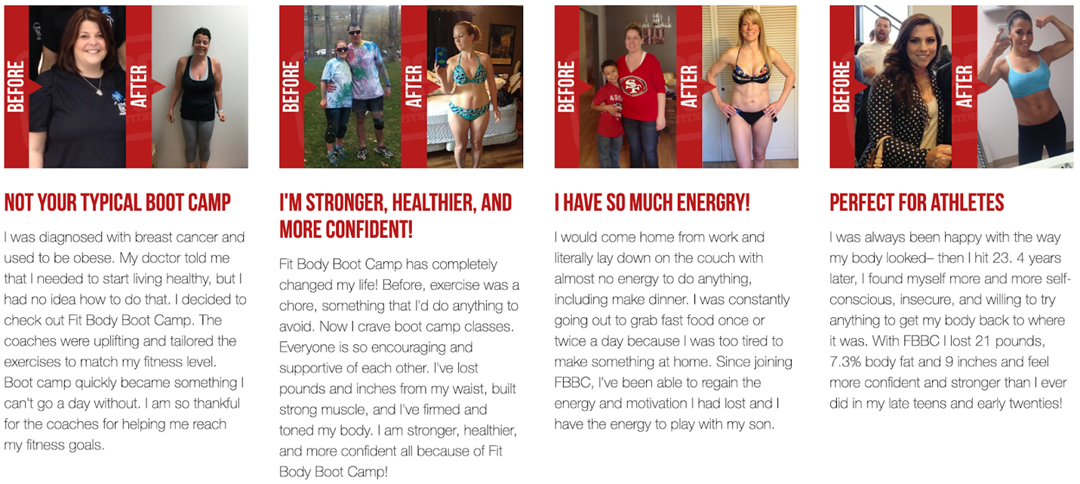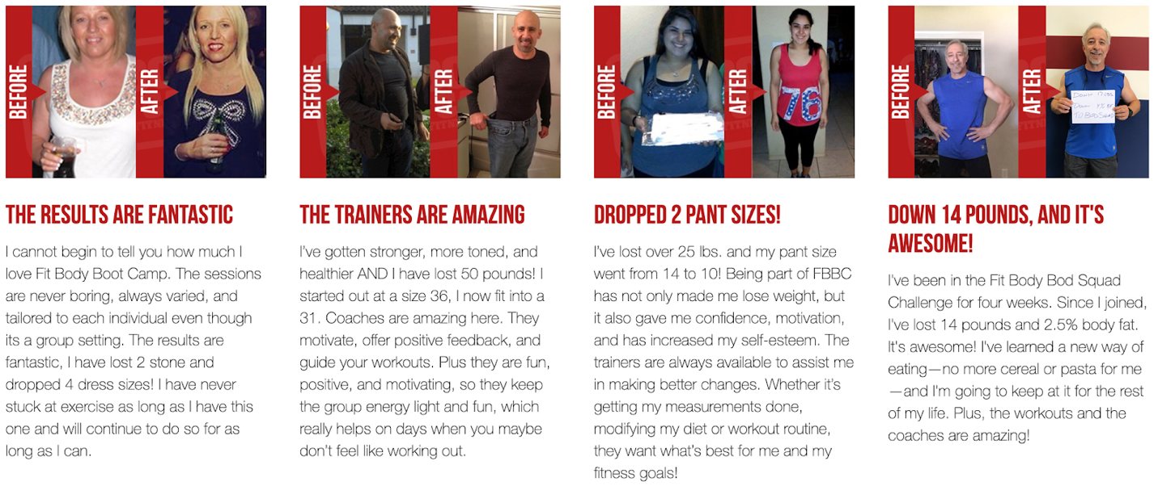

With 2 free weeks, you truly have nothing to lose -- only the once in a lifetime opportunity to get the body and healthy lifestyle of your dreams for the lowest price I’ll EVER offer again.

BUT ONLY IF YOU COME IN OR REACH OUT BEFORE [DATE]!

Talk soon,

[SIGN OFF]

Email 3 -- send this 2 days before price increase.

Subject: FWD: 48 HOURS LEFT -- best price EVER on fat loss
Hey,

Today and tomorrow are the last call for your friends and family to get my 2 week FREE trial with the option to be grandfathered in BEFORE the price increase!

Please forward this message to them ASAP :)

Thank you!

---------- Forwarded message ---------
From: [YOUR EMAIL]
Date: [TODAY’S DATE]
Subject: 48 HOURS LEFT -- best price EVER on fat loss
To: XXXXX

Heads up: only two days left before I raise my prices permanently for all new members.

That means for the next 48 hours only, you can sign up and be grandfathered in FOR LIFE at my lowest rate -- and get a bargain on the weight loss and ideal body you desire!

And, truth be told, I’m bending the rules for a little bit because I know you’ve been thinking about Fit Body Boot Camp for a while now.

If this is the nudge you need to finally achieve your dream body, take back control of your health find your confidence again, and experience a head-turning physical transformation…

Then I’m happy to bend the rules for you!

So here’s the deal: reply to this email, call me at [PHONE NUMBER] or come into boot camp within the next 48 hours and I’ll start you on a 2 WEEK FREE TRIAL with the option to take advantage of my current, low membership rate at the end.

Yes, this means you’ll technically be past the deadline for the price increase…

BUT, I want to make sure you’re 100% confident in your decision to sign up, which is why I’m giving you those 2 week free.

Take the two week trial and see if the fast results, positive community, and smart, lifestyle-friendly nutrition coaching here at Fit Body Boot Camp is right for you.

And for a sneak peek, check out these stories from real clients:

With 2 free weeks, you truly have nothing to lose -- only the once in a lifetime opportunity to get the body and healthy lifestyle of your dreams for the lowest price I’ll EVER offer again.

BUT ONLY IF YOU COME IN OR REACH OUT WITHIN THE NEXT 48 HOURS!

Talk soon,

[SIGN OFF]

