Prospect Nurture
Day 1 Email
Subject: Legend of the hidden six pack!
Hi Sue,
Shawn S. was, like many guys, curious about how to get six pack abs, but little did he realize...
The magic of the six pack was inside him all along...
Seriously, though, whenever you see one of those diagrams of the human body, the muscles always have six pack abs...so if you want six pack abs, or even just lean and toned abs, all you need to do is come to boot camp and shed that extra weight!
"But Coach, is it really that simple?" you may be wondering.
Well...just take a look at Shawn S. and see what he has to say!
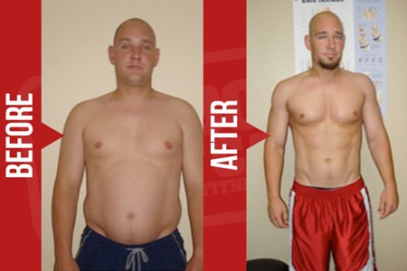
"I decided to get back into shape weighing 250lbs. My trainer recommended an eating style, not a diet, and I was told with regular intense exercise my goal would become reachable. Since then I have lost a grand total of 20lbs. My goal is complete health; physique, metabolic, flexibility, and great eating habits."
So, what do you think?
Has the magic of a lean, toned, sexy body been waiting inside you all along?
I believe so...
And if you need help finding the magic, just let me know!
- [StaffMemberAssigned]

Day 3 Email
Subject: this one piece of advice will change everything…
Hey Sue,
Yesterday I was talking to another FBBC member, Salina Littleton, and I asked her A) if I could share her amazing before and after picture and B) if she could share her one best piece of advice for people who are considering Fit Body Boot Camp...
For question A, she said yes. After all, who wouldn't want to share this?!
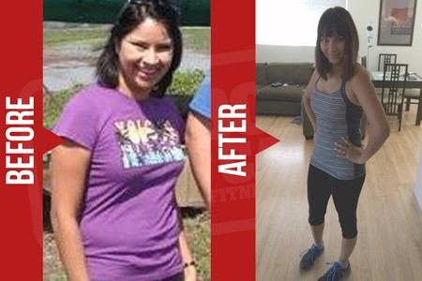
And for question B, she said this:
"Do it! Seriously do it! It is a life changer. But, you have to really commit to it. Take it seriously. This is your body and your health. Take full advantage of all that is available to you through Fit Body Boot Camp. The trainers are amazing and motivating!"
Great advice Salina!
Hope you found that helpful :)
- [StaffMemberAssigned]

Day 5 Email
Subject: does losing weight mean eating less?
Hi Sue,
Do you think losing weight means eating less?
If you do, then I'm about to blow your mind.
See, most of my members here at Fit Body Boot Camp end up eating MORE food than they did before signing up. That's right: more, not less.
Now, there's all kinds of complicated nutritional science I could go into here to explain why that is...
...or I could just show you a real life example, like Cara. Take it away, Cara!
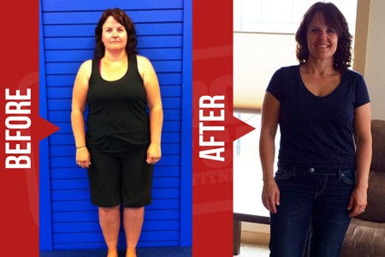
"With the proper tips from my Fit Body Boot Camp trainer, guidance from her and the awesome team behind me, I have DOUBLED my calorie intake, dropped 6 pant sizes and 40 pounds! More importantly, I FEEL GREAT! I have way more ENERGY, not tired like I was before, a positive outlook and I FEEL STRONG! Love the way I feel!!! FBBC has helped me create a new lifestyle!!!"
That's right, she DOUBLED her calorie intake and that HELPED her lose 40 pounds!
This is why I always tell people to stay away from crash diets, weight loss pills, and all that other nonsense.
REAL health and fitness is so much more fun, so much safer, and WAY more effective!
Of course, I'm not saying you should go out and eat twice as much food. You need the guidance of a fitness expert to get the results you're looking for, just like Cara said.
Talk soon!
From The Club Staff (dummy [defaultsignature] replacement)
P. S. Hey, would you like to get real weight loss results in a healthy way, just like Cara? I want to help you do that, and that's why I've set up a special introductory program just for you. Reply to this email or click here [classschedule] to schedule an orientation and learn more!

Day 7 Email
Subject: she was pre-diabetic. Now…
Hi Sue,
I'm literally tearing up as I type out this email, because what I'm about to share with you brings me so much hope and joy.
Diabetes is no joke -- I've watched first-hand what kind of effect it can have on people's lives.
So, whenever I'm in consultation with someone and they mention they're pre-diabetic, I leap into action!
And by that, I mean I show them real examples of people who got healthy in those same circumstances, like Brenna McNeil here..
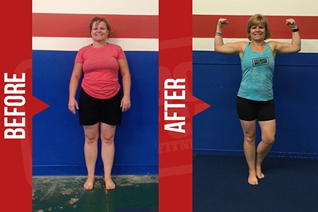
"My doctor told me my blood sugar was 106 and I was pre-diabetic. That's all it took to get me to boot camp. I was already making excuses to stay home instead of going out and I never wore shorts or short sleeves. After a year and several Game Changer's I've lost 40 pounds, 12% body fat and dropped my blood sugar to 86."
I LOVE helping people look and feel their best. The only thing I can think of that I love even more is giving people a longer, higher-quality life. That's what I live for -- my mission in life.
So, believe me when I say that a fit, healthy body is ALWAYS possible for you when you make the right choices.
Stay healthy! Talk soon!
From The Club Staff (dummy [defaultsignature] replacement)

Day 9 Email
Subject: He got results, period.
Hi Sue,
Let's play a little game...
Put your hand in the air right now, whichever hand you aren't using to scroll through this email.
Now put that hand back down if you have ever...
- gone to the gym and spent most of your time chatting with friends, getting water, and taking breaks instead of working out
- counted walking from one end of the mall to the other as a workout
- ordered a big, greasy slice of pizza and tried to cancel it out with a "diet" soda
- ordered an at-home workout machine, used it once, put it in the closet, and completely forgot about it
- taken a selfie with your phone WAY above your head so you could "work the angles"
I could go check my crystal ball on this one...but I'm pretty sure your hand is down by now...and I'm preeeeeettttttttty sure I had to put my hand down too ;)
Look, we all have little ways of pretending to make progress while still staying in our comfort zone. That's why it's important to seek out RESULTS, not just what feels good in the moment.
That's why I find Thiago Melo so inspiring. He's a member from another FBBC who just announced his own awesome transformation.
Here, check it out:
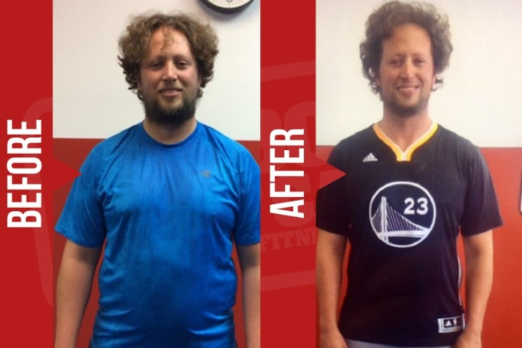
"It finally hit me: At 34 and standing 6'3" tall, I was 270 lbs, always tired, unproductive, and uncomfortable with my shirt off. Thanks to FBBC, I lost 40lbs and 5 inches around my waist, and I was even able to play basketball with energy again. FBBC's flexible schedule, 30 minute workouts, eating guidance, and tight-knit culture got me results, period. If you are disciplined, consistent, and patient enough, it will change your life too!"
Results - period!
That's what we're all looking for, right?
Talk soon,
From The Club Staff (dummy [defaultsignature] replacement)

Day 11 Email
Subject: he found the fountain of youth!
**Cue Indiana Jones Music***
In a far-off temple...hidden in the misty depths of an ancient jungle...there lies a fountain that pours from the mouth of a golden lion statue, and...
**Record Scratch**
Wait, hang on. This is not a pitch for a new Indiana Jones movie -- this is an important message about your health and fitness goals!
See, a lot of people look at weight loss, healthy living, and even de-aging as these magical things only reserved for celebrities and the ultra-wealthy.
But the truth is that ANYONE can have the body of their dreams IF they have the right guidance and accountability.
Here, just look at Kelvin Coenen. He's just a regular guy who signed up for Fit Body Boot Camp and has a lot to say about it!
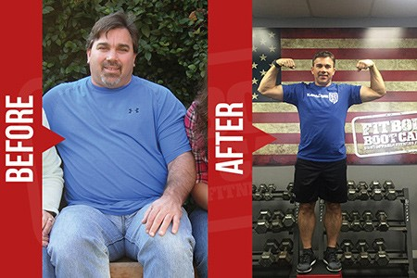
"I tried various things but my weight continued to increase while my energy level declined. I was not in a happy place. I won't lie, I wasn't sure I'd be back after my first class, but I knew that if I did not come back the next day I'd never be back again. I'm actually beginning to feel like I've found a fountain of youth. I LOVE what the exercise does for me physically and mentally. More energy, more self-confidence, new friends all striving to improve our health and fitness. All THANKS TO FBBC!"
Like I said -- regular guy, but with our program, he got outstanding results!
Talk soon,
From The Club Staff (dummy [defaultsignature] replacement)
P. S. Have we really found the "fountain of youth" like Kelvin says? Only one way to find out! Here, I'll make it even easier for you: we have a special introductory program you can check out right now if you reply to this email or click here [classschedule] to schedule a consultation. See you soon!

Day 13 Email
Subject: does beauty end at 23?
Hi Sue,
Okay, I need to vent about something for a second...
It REALLY grinds my gears when people say that women stop being beautiful by a certain age.
23, 30, 50 -- I don't care what the number is, the reality is that ANY woman can look beautiful at ANY age with the right fitness program.
Here, just look at Ashley and listen to what she has to say about it:
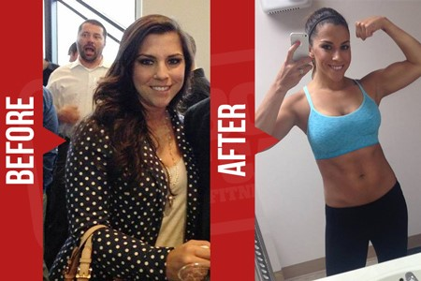
"I was always been happy with the way my body looked -- then I hit 23. 4 years later, I found myself more and more self-conscious, insecure, and willing to try anything to get my body back to where it was. With FBBC I lost 21 pounds, 7.3% body fat and 9 inches and feel more confident and stronger than I ever did in my late teens and early twenties!"
See! Beauty and confidence are a CHOICE -- not a number that's decided for you.
Make the right choices, and you can be happy, healthy, and gorgeous every day of your life.
Talk soon!
From The Club Staff (dummy [defaultsignature] replacement)

Day 15 Email
Subject: afraid to post pictures online?
Hey Sue,
I can't tell you how many women I talk to who are afraid to post pictures of themselves online, even on their own, private Facebook pages, because they don't like the way they look.
It bums me out...but it also motivates me to work even harder to help those women get fit and confident so that they CAN post pictures of themselves and show off.
That's right -- show off. If you've got a body you love, you deserve the chance to show it off!
Just like Sandra Borja...an FBBC member who was only too happy to let me share her photo here ;)
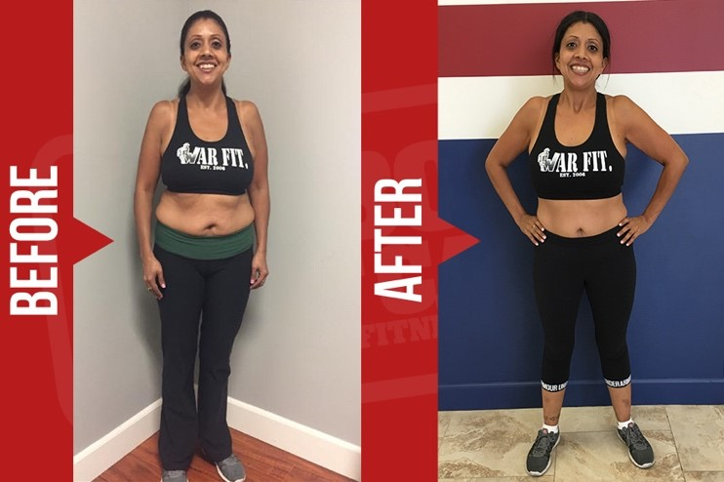
"6 months ago, I began to work out to take care of my kids and myself. After 101 classes and support from family and friends, I've lost over 20 pounds and cut my body fat from 34-37% to 25-27%. Now I post more pictures of myself online than ever before!"
Pretty awesome, right?
Talk soon,
- [StaffMemberAssigned]

Day 15 Text
Hey [firstname], just checking in from FBBC - are you doing any kind of fitness/nutrition program to help you achieve your health and wellness goals? Lmk!

Day 17 Email
Subject: wait, is that really her?!!
Hey Sue,
Sometimes I like to go back and look at before and after photos of previous FBBC clients just to remind myself of my mission here...
...and I swear, there some of these pictures where I can hardly believe that it's the same person on both sides!
For example, check out Laurie Blizzard here:
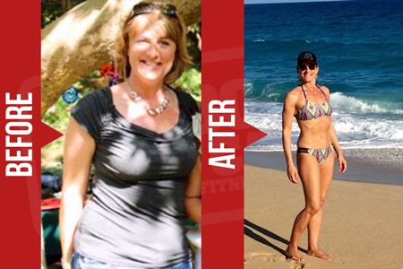
I mean seriously, look at her! If I wasn't looking at this direct quote from her, I would swear I was looking at two different women.
But nope, those are both Laurie! Here, check out what she had to say:
"My goal was to trim some more inches, reduce my body fat % and to get stronger by building muscle and body definition. FBBC helped me do just that and at 47 years old I am excited to finally have the beach bikini body I had always wished for! I am definitely in the best physical shape of my entire life!"
Watching transformations like this is so inspiring. THIS is why I love what I do! Hope you find it inspiring as well :)
Talk soon!
From The Club Staff (dummy [defaultsignature] replacement)
P.S. I want you to get amazing, jaw-dropping results just like Laurie did! Click this link to set up a consultation [classschedule] or reply to this email to see about our special introductory program.

Day 19 Email
Subject: Is she crazy?
Hi Sue,
Okay, imagine for a second a woman came up to you and told you that she was enjoying her 40s more than she enjoyed her 20s...
Would that make sense to you, or would you think she was crazy?
I know a lot of people who miss their twenties and talk about them like they're these golden years they can never get back...
That's when I had so much more energy...
That's when I could do whatever I wanted...
That's when I was skinny...
But personally...I like to keep marching forward. The best is yet to come! Just like my friend Michelle Littel. Just look at how much she transformed working at FBBC!
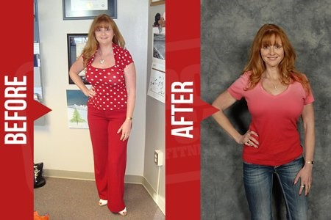
And here's what she had to say about it:
"With Fit Body Boot Camp, I was thrilled at the idea of being able to get an intense workout, year-round! My trainer does a great job of motivating me and making me realize I can do more than I ever thought possible. I have seen great results on the scale and also in my clothes! I am in better shape and feel better at 40 than I did in my 30's or even 20's!"
So, here's to getting happier, healthier, and stronger every day :)
Talk soon!
From The Club Staff (dummy [defaultsignature] replacement)

Day 21 Email
Subject: 2 kids? No problem!
Hi Sue,
Who said having a kid means you need to give up your beach body?
Heck, who said having TWO kids means you need to give up your beach body?
I don't know who said that, but FBBC member Dana Caldwell definitely did NOT!
Instead, she said this:
"After a beach vacation, I looked back at the pictures and saw the weight I had packed on with having 2 kids. So I tried it all! Nothing has benefited me like Fit Body Boot Camp. The trainers are super supportive and the workouts started to chisel out the form I desired! Before my next beach vacation I was ready to rock a new toned body! And fbbc is the only way I achieved it! I will continue to grow and improve and enjoy the environment at fbbc!"
And she looks like this:
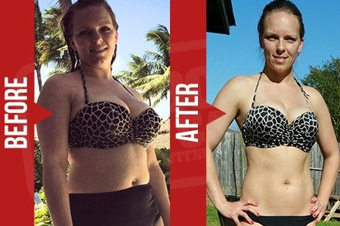
Moms of the world -- forget the doubters! It's your time to SHINE.
Talk soon,
From The Club Staff (dummy [defaultsignature] replacement)

Day 23 Email
Subject: the secret to dropping 40 in…
Hi Sue,
Let's say, hypothetically, a friend of yours wanted to lose 40 inches from her waist but she had absolutely no idea how to start.
What would you tell her to do?
Well...in my mind, the fastest, easiest path to success with ANYTHING in life is this:
Find someone who has already accomplished what you want to accomplish...and ask them how they did it!
Case in point, I know someone who did drop 40 inches from her waist. Here, see for yourself:
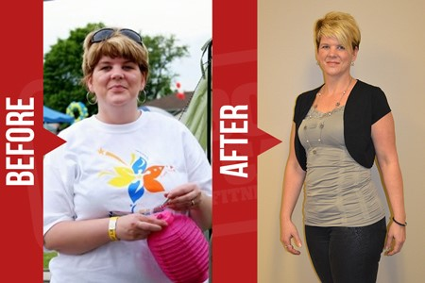
That's Jenn G. What's her secret? Well, here's what she had to say!
"I have lost 50lbs and over 40 inches. I have learned so much about nutrition and exercise and how to make them both work together. What I have gained the most is the Fit Body Boot Camp family, the support and encouragement you get from the other campers is truly amazing. I do not know where I would be now without FBBC!!!"
So, there you have it: her secret is Fit Body Boot Camp!
Be sure to tell your hypothetical friend about us ;)
Talk soon!
From The Club Staff (dummy [defaultsignature] replacement)
P.S. I want you to get dramatic results like Jenn did, and I found a way to make it even easier for you! It's a special introductory program -- to learn more, just reply to this email or click here [classschedule] to schedule an orientation.

Day 25 Email
Subject: Inspiring (and hilarious)!
Hi Sue,
Just wanted to share an inspiring (and hilarious) quote with you from another FBBC member! Her nameâ€™s Jennifer Shaffer -- here, check this out:
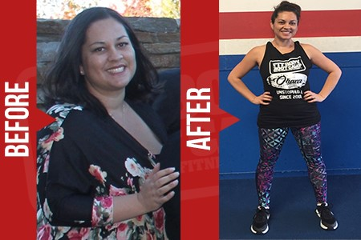
"I love you my fat mommy' That's what my son would call me, and it's who I became - 'Fat. Sad. Mommy.' I was feeling overweight and tired, and couldn't even play soccer with my kids. I started saying things like 'I'm 36 it's too late for me to be happy fit and healthy. It's gonna take so long and it's probably not gonna even work.' Then I went to boot camp and went to work. I've lost 60 pounds now, I can run around with my kids, and now they call me 'Bada** Mommy!'"
Kids, right?
Seriously, huge shout out to Jennifer for her commitment and her results!
Hope you got a good laugh out of this -- talk soon!
From The Club Staff (dummy [defaultsignature] replacement)

Day 27 Email
Subject: Want to look like her?
Hey Sue,
Imagine going from feeling gross and out of shape...
...to being in such good shape that other people envy you and secretly wish they could be like you.
An impossible fantasy?
Not according to Sharon Vanbelle -- just take a look at her Before and After pictures here and read what she had to say...
"Physically I could see the changes, which helped me mentally, and I did not feel guilty for taking 45 min out of my day for me when I had so much to do for others. Now I look at food as my fuel balancing good clean carbs, proteins and fats and eating more than 2 meals a day. My beginning goal was to lose some weight and inches and become stronger. The challenge really kicked me in gear. The best thing that has happened is my health!!!!!! Being a part of the FBBC family!"
Seriously, WOW!
Pretty incredible, right?
Talk soon,
From The Club Staff (dummy [defaultsignature] replacement)

Day 29 Email
Subject: how soon will you feel the difference?
Hi Sue,
I get a lot of people asking me how soon they'll feel the difference once they start working out at Fit Body Boot Camp, and I figured the best way to answer that question would be to ask a real member -- someone who's personally gone from out of shape to GREAT shape in a short time!
Xitlaly Salcedo was kind enough to give me a quote and even a picture I could share! Check it out:
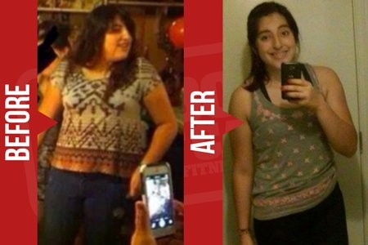
"FBBC not only provides you with high quality workouts, but the staff and trainers also provide a great environment where no matter how unsure you feel about yourself you will always feel welcomed. Within a week of working out at FBBC, I could already feel a difference, and when I got my first measurements, I was stunned with my results. FBBC has been the best exercise program I've ever purchased!"
There you have it -- you'll feel the difference within a week :)
Talk soon!
From The Club Staff (dummy [defaultsignature] replacement)
P. S. Hey, would you like to get stunning fat loss results in a healthy way, just like Xitlaly? I want to help you do that, and that's why I've set up a special introductory program just for you. Reply to this email or click here [classschedule] to schedule an orientation and learn more!

Day 30 Text
Checking in from Fit Body Boot Camp - was thinking about you! Are you ready to start your fitness and fat loss journey?

