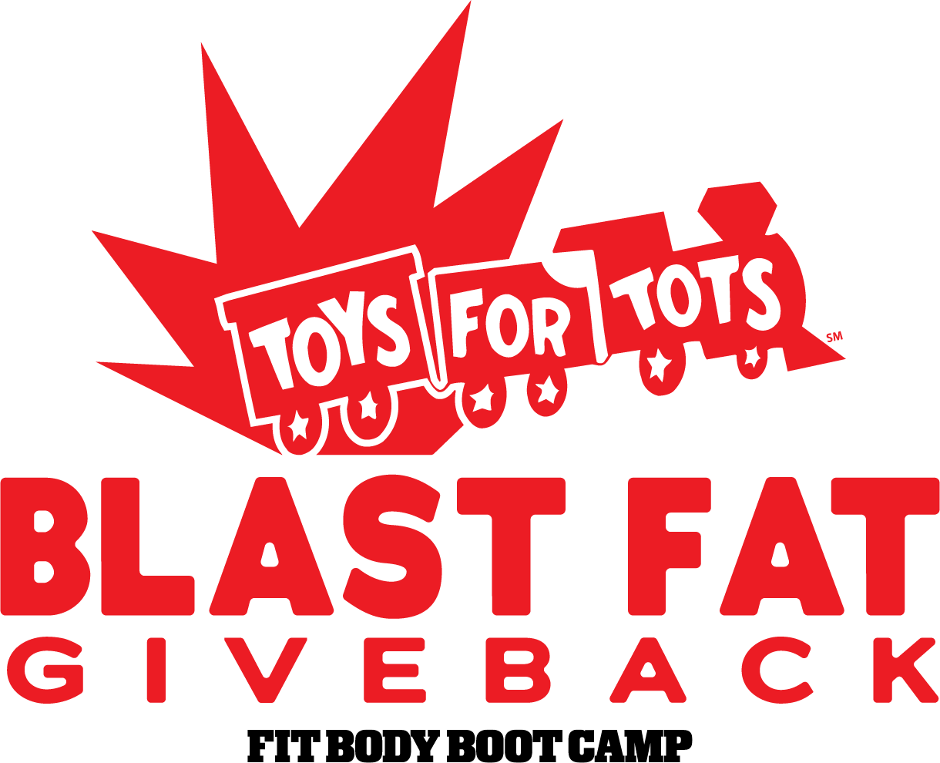
☑ YES! I want to feel great while getting lean, fit and toned with the Blast Fat, Give Back Promo for only…

□ $77 Donation for the Toys For Tots Foundation.

I understand that my results are guaranteed or I will get 100% of my money back!

If you signed up online, please put “ONLINE” on the line below.

AUTOMATIC PAYMENT AUTHORIZATION: I, the Client, hereby authorize [FBBC LOCATION] to charge to my credit card or debit card for the amount listed above.

#_____________________________________________________________________
Expiration Date ________ /_________ /_________

Card Type: □ AMEX □ DISCOVER □ MASTERCARD □ VISA

Any and all payments due to [FBBC LOCATION] as indicated above. I, the Client, further authorize my credit card company or bank to make payment(s) to [FBBC LOCATION] by the method(s) indicated above and to post it on my account.

TERMS AND CONDITIONS
The Blast Fat, Give Back program will automatically be considered active at time of signing (or online sign up, whichever came first) and until canceled as described in the Cancellation Policy. This training special includes unlimited bootcamp to be completed within the 21 consecutive days. Failure to comply with program guidelines can result in program termination at any time by [FBBC LOCATION]. ROLLOVER: After the initial 21 days this program will automatically roll over into The "Unlimited VIP Program" (see back of form) but can be cancelled anytime during the 21 day program. The FBBC Unlimited VIP Program is a 12 month program and will automatically be considered active after the 21 days has been completed and until canceled as described in the Cancellation policy. The program includes unlimited bootcamp sessions per month. Billing will recur every 30 days from original VIP program start date at a maximum rate of $247 /mo. Other agreements made in writing can supersede this agreement. CANCELLATION POLICY: Client must give any and all notice of cancellation by Email to [EMAIL] at least 15 business days prior to the above stated debit date. (Please note… Even if you notify your instructor, you still are required to send an email to above address) Save a record of this email to serve as your cancellation receipt. REFUNDS: No refunds shall be issued for any services purchased unless stated in writing. MEDIA: I hereby grant [FBBC LOCATION] permission to interview me and/or to use my likeness in photograph(s)/video in any and all of its publications and in any and all other media, whether now known or hereafter existing, controlled by [FBBC LOCATION] in perpetuity, and for other use by [FBBC LOCATION]. I will make no monetary or other claim against [FBBC LOCATION] for the use of the photograph(s)/video. I certify that I have fully read and understand the terms of this Agreement (front and back) and will comply with the contents herein.

Full Name______________________________________________________
Street Address________________________________________________________
City_________________________________________________________ Billing Zip Code___________________
Cell Phone___________________________________ Email__________________________________________

Client Signature _____________________________________________ Date ______ /______ /______

WAIT! It Gets Even Better!

There's even more great news for you! So many people wanted to continue on after their amazing 21 day journey the last time that I wanted to make the decision for you to reach your dream body a “no brainier.”

Just like these people…

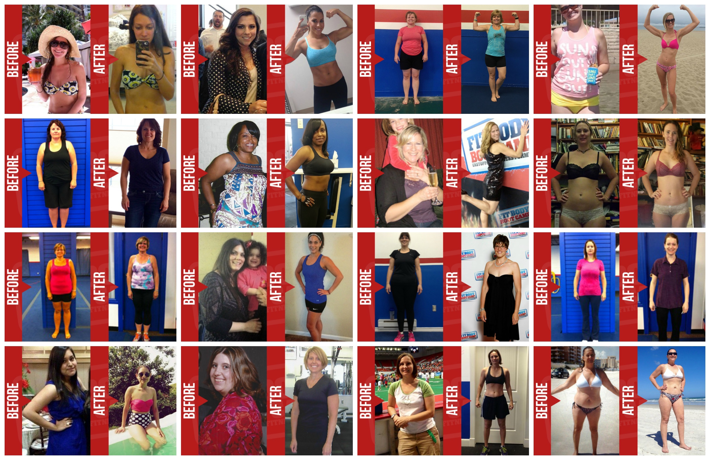

So here's the special opportunity I have just for you!

SIMPLY CHOOSE ONE - SPECIAL OFFER TODAY ONLY!

YES! I WANT TO CONTINUE GETTING LEAN & TONED AT THE ABSOLUTE
LOWEST DISCOUNTED PRICE POSSIBLE!
I want to stay fit, lean and healthy forever. I agree to join the 12-month FBBC Body Maintenance Program: an UNLIMITED training program for only $97 for the first month and then the low discounted price of $197/mo after that. I know there is absolutely NO RISK because I can cancel this commitment any time during the 21 Day Blast Fat, Give Back Promotion.

 I’m not interested in saving money so I’ll just choose Month-to-Month
I agree to join your month-to-month training program for only $197 for the first month and then the regular price of $247/mo after that. I know there is absolutely NO RISK because I can cancel this commitment any time.

