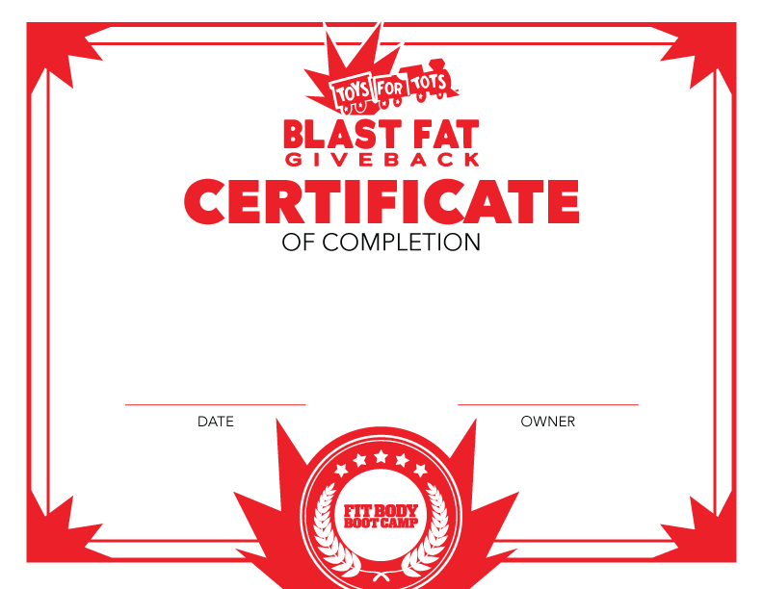

This certificate is hereby presented to
FIRST NAME LAST NAME
for active participation and completion of our Blast Fat Give Back Challenge with our
Fit Body Boot Camp family Insert Date.

